**OBJECT IDENTIFICATION (WEB UI)**

Navigate to https://material.angular.io/components/table/overview

1. **Table Basic Example** laying under Getting Started

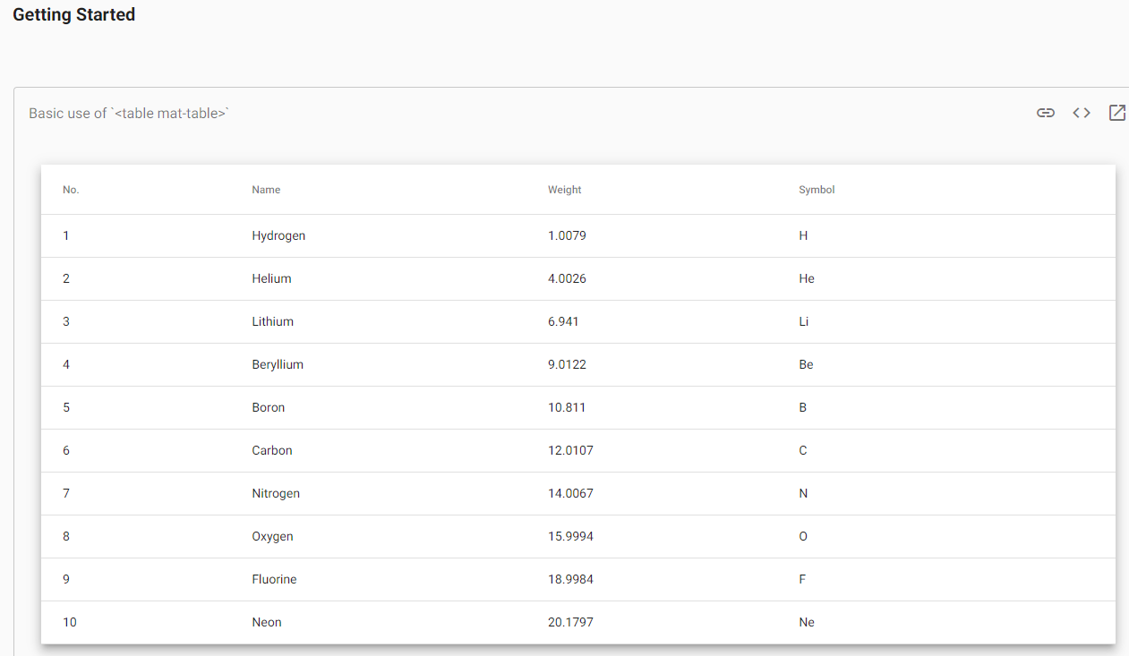

**XPATH: //example-viewer[@id='table-basic']**

**CSS: example-viewer[id='table-basic']**

2. Identify **Weight** based on Name in the above table. Ex: Boron is 10.811

**XPATH:**

**//example-viewer[@id='table-basic']//table[contains(@class,'mat-mdc-table')]//td[contains(text(),'Hydrogen')]/following-sibling::td[1]**

**//example-viewer[@id='table-basic']//table[contains(@class,'mat-mdc-table')]//td[contains(text(),'Helium')]/following-sibling::td[1]**

**//example-viewer[@id='table-basic']//table[contains(@class,'mat-mdc-table')]//td[contains(text(),'Lithium')]/following-sibling::td[1]**

**//example-viewer[@id='table-basic']//table[contains(@class,'mat-mdc-table')]//td[contains(text(),'Beryllium')]/following-sibling::td[1]**

**//example-viewer[@id='table-basic']//table[contains(@class,'mat-mdc-table')]//td[contains(text(),'Boron')]/following-sibling::td[1]**

**//example-viewer[@id='table-basic']//table[contains(@class,'mat-mdc-table')]//td[contains(text(),'Carbon')]/following-sibling::td[1]**

**//example-viewer[@id='table-basic']//table[contains(@class,'mat-mdc-table')]//td[contains(text(),'Nitrogen')]/following-sibling::td[1]**

**//example-viewer[@id='table-basic']//table[contains(@class,'mat-mdc-table')]//td[contains(text(),'Oxygen')]/following-sibling::td[1]**

**//example-viewer[@id='table-basic']//table[contains(@class,'mat-mdc-table')]//td[contains(text(),'Fluorine')]/following-sibling::td[1]**

**//example-viewer[@id='table-basic']//table[contains(@class,'mat-mdc-table')]//td[contains(text(),'Neon')]/following-sibling::td[1]**

**CSS:**

**tbody[class='mdc-data-table__content'] tr:nth-child(1) td:nth-child(3)**

**tbody[class='mdc-data-table__content'] tr:nth-child(2) td:nth-child(3)**

**tbody[class='mdc-data-table__content'] tr:nth-child(3) td:nth-child(3)**

**tbody[class='mdc-data-table__content'] tr:nth-child(4) td:nth-child(3)**

**tbody[class='mdc-data-table__content'] tr:nth-child(5) td:nth-child(3)**

**tbody[class='mdc-data-table__content'] tr:nth-child(6) td:nth-child(3)**

**tbody[class='mdc-data-table__content'] tr:nth-child(7) td:nth-child(3)**

**tbody[class='mdc-data-table__content'] tr:nth-child(8) td:nth-child(3)**

**tbody[class='mdc-data-table__content'] tr:nth-child(9) td:nth-child(3)**

**tbody[class='mdc-data-table__content'] tr:nth-child(10) td:nth-child(3)**

3. Identify **API Tab**

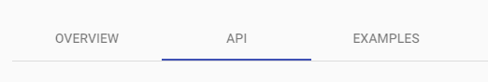

**XPATH: //a[@id='mat-tab-link-2']**

**CSS: a[id='mat-tab-link-2']**

4. In **API tab**. Identify all elements under **Interfaces** on the right side except the first item (4 items)

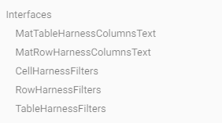

**XPATH:**

**//a[contains(text(),'MatRowHarnessColumnsText')]**

**//a[contains(text(),'CellHarnessFilters')]**

**//a[contains(text(),'RowHarnessFilters')]**

**//a[contains(text(),'TableHarnessFilters')]**

**CSS:**

**nav[aria-label='Testing Table of Contents'] a:nth-child(11)**

**nav[aria-label='Testing Table of Contents'] a:nth-child(12)**

**nav[aria-label='Testing Table of Contents'] a:nth-child(13)**

**nav[aria-label='Testing Table of Contents'] a:nth-child(14)**

***Note:***

*It might be noticed that we will bear some side effects when interacting with the CSS selector. You can describe the idea if it occurs.*

**Due date:** 09.Sep.2023